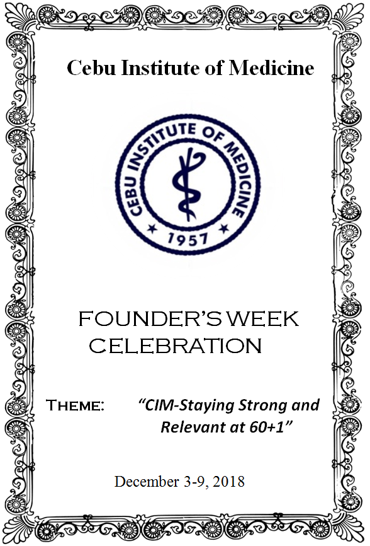
CIM Hymn

CIM Dear Alma Mater
Our thanks for everything
Excellence in us you foster
As healers and as friends
Source of pride & inspiration
In our hearts and dreams

You’re truly our one and only
CIM

The richness of our vision
That fills our very soul
We cherish in our mission
Of caring and to cure

Source of pride & inspiration
In our hearts and dreams
You’re truly our one and only
CIM
You’re truly our one and only
CIM

CIM Founder’s Week Activities
December 03-09, 2018
ecember 03-09, 2018

Day 1

December 03, 2018 (Mon)
8:00 am – 5:00 pm CIM Medical World Congress
Radisson Blu Hotel, Cebu City
CIM Class 1993

Day 2
December 04, 2018 (Tue)
8:00 am– 5:00 pm CIM Medical World Congress
Radisson Blu Hotel, Cebu City

6:00 pm Fellowship Night
Radisson Blu Hotel, Cebu City
CIM Class 1993

December 05, 2018 (Wed)
8:30 am Formal Flag Ceremony at CIM Quadrangle
Short Opening Ceremonies
Opening of Photo Exhibit
(per department) at CIM Lobby

9:00 am Bioethics Forum
Theme: ‘’ Virtue Ethics
(Excellence, Compassion, etc)
Speaker: Fr. Alfonso Suico
Amphi 3

2:00 pm Utokay
Amphi 3

6:00pm Student’s Night
Mandani Bay

December 06, 2018 (Thur)
8:30am Memorial Mass
CVGH Divine Mercy Chapel

10:00am Floral offering for Dr. Jacinto Velez Sr., Dr. Jacinto Velez Jr. & Mrs. Epifania Velez
Cempark

11:00 am CIM Family Luncheon
CIM Main Social Hall

2:00 - 4:00 pm 29th Annual Dr. Jacinto Velez Sr. Memorial Lecture
Theme: ‘’ The Physician with a Heart-
Service in the Face of Adversity”
Speaker: Dr. Raymund Cagape (Class 1987)
Amphi 3

December 07, 2018 (Fri)
8:30-11:00nn Recognition Ceremonies
CIM Main Social Hall

1:00-4:00pm Research Paper Contest
Poster Presentation (CIM Lobby)
Oral Paper Presentation (Amphi 3)

December 08, 2018 (Sat)
8:30am Alumni Day Homecoming
Awarding of Most Outstanding Alumni 2018 Recognition of Silver (1993) and Golden (1968)
Amphi 3

12:00-1:30pm LUNCH
CIM Main Social Hall

December 09, 2018 (Sun)
9:00-12:00nn Well Baby Contest
CIM Lobby

