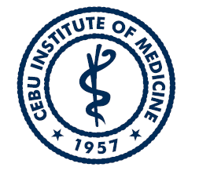  `` | POLICY MANUAL |  | Document No. | QMS-POLICY-001
 |  |  | Version No | 03
 |  |  | Date of Approval | October 21,2022
 |  |  | Date of Effectivity | November 1, 2022
Department / Committee |  | QUALITY ASSURANCE COMMITTEE
Document Name |  | QUALITY ASSURANCE SYSTEM

Overview
The Cebu Institute of Medicine, one of the pioneer medical school in Cebu was founded in June 1957 initially in collaboration with the Cebu Institute of Technology. Through the years it has evolved to become a non-stock, non-profit medical learning institution in 1966 when it was first named as the Cebu Institute of Medicine. The school ranked as level IV category by the Board of Medical Education in 1987 and was awarded as a Center of Excellence for Medicine in 1996 by CHED. CIM was also made Autonomous by 2001 and had PAASCU level III accreditation and ranked number one among the Top Performing School in the country 2001 – 2018. To help achieve excellence in research researches have been part of the curriculum for all three-year levels with the finished paper as requisite for promotion to higher level paving for the creation of the Clinical Epidemiology Unit that reviewed the technical soundness of the research proposals of the school. This was adequately supported from the Level CIM CVGH IRB that ensures ethical correctness of the research outputs. In all its endeavors the CIM has an active collaboration with the Cebu Velez General Hospital. The Cebu Velez General Hospital (CVGH) is the main training hospital of the Cebu Institute of Medicine (CIM). The CIM shares with the hospital its clinical and teaching departments which include the departments of Internal Medicine, Surgery, Pediatrics, Family Medicine, OB-GYN and Ophthalmology, and ENT since it started its training programs. Just recently, owing to the current worldwide thrust on quality in medical education, the Cebu Institute of Medicine has collaborated with the hospital’s Quality Assurance Committee in ensuring topnotch medical education as a necessary requirement for graduating future “physicians with a heart.”

